Boroughmuir High School: Senior School Study Support 2025-26 February

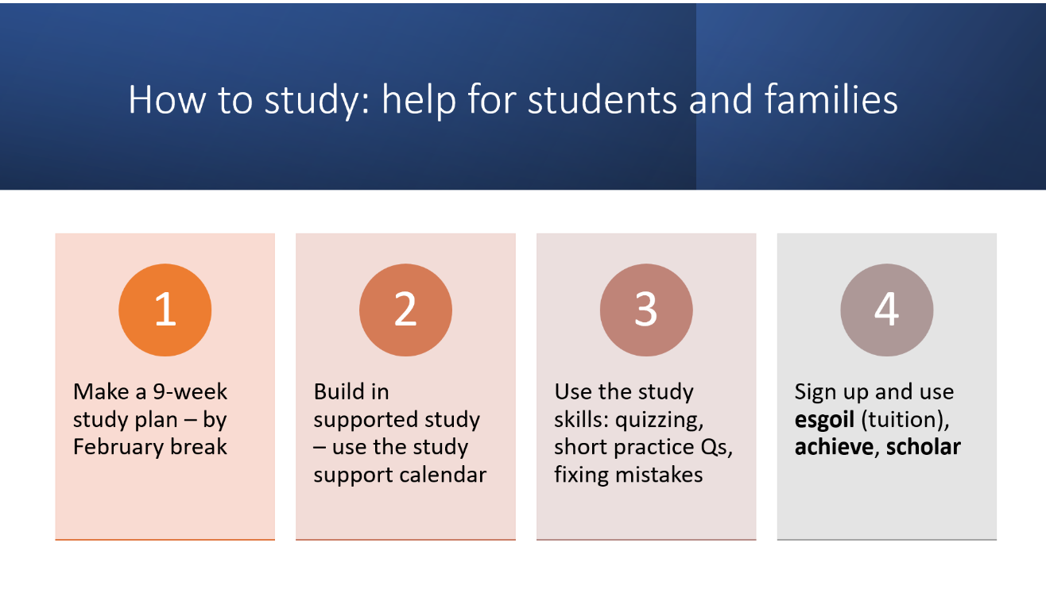

SQAinformation Learner support for National Qualifications - SQA
All home practice and assessment deadlines are on TEAMS on students’ iPads. Open up the Teams app and click on ASSIGNMENTS or CALENDAR.

Study support calendar
Many departments offer study support on top of all their classroom help. Here are the current sessions offered. Students will also be told by their teachers. This will update through the year, so students should continue to check with their teachers, on noticeboards and other communications such as Teams.
Day | Breakfast or Lunch- room and teacher | After school – room and teacher
Monday | Lunch  - Business – Room Rota Posted on Teams and in department  - Computing – Miss Stevenson room x2.19 (N5/H)  - PE – LG05 Miss Shiel | - Music – Miss MacLeod G01 all levels  - RMPS/ Philosophy Mr. Igoe Dual Teaching all levels  - Economics - Room x116 (N5/H)  - N5 English – Ms Baskerville Room 1.14
Tuesday | Lunch  - Chemistry – Dr MacMillan room 3.13  - Practical Cookery – Mandy Mitchelmore LG10  - N5 English – Ms Baskerville, room 107 | - Health and Food Technology Miss Davidson LG03  - Maths/ Apps study support 2.11 Ms Weiss/Mr Williams  - Media support G.08 Miss Dunlop  - N5 English – Miss Tench, room 1.11  - Higher English – Ms Stratton, room 1.14  - Physics- room 3.01
Wednesday | - Chemistry – Mrs Jaeger room 3.12  - Economics (N5/H) – S6 Pupils Room x116 (supported by Miss Boag) | - Geography N5 / Higher (Miss Sloan x3.27)  - History N5/Higher (Mr Compston x3.26)  - Drama LG11  - Homework / study support- 3.30 in library
Thursday | - The Maths and Science support group with Mr Beard and Miss McLeod is on Thursdays from 7.45 – 8.30 am in lower ground. It’s a great opportunity to get help with your Maths, Science homework and improve your numeracy skills. Get up early and don’t miss out on support and a tasty croissant and drink!  - Chemistry – Mrs Hearnden room 3.15  - Practical Cookery – Mrs Sneddon LG02  - Health and Food Technology Mrs Snaddon & Miss Davidson LG03  - Computing – Miss Stevenson room x2.19 (N5/H)  - All levels English – initially folio then exam revision – Ms Stratton, room 114 | - Modern Studies N5 (Mr Cogan rm X2.18)  - Modern Studies Higher (Mr Beattie x2.17) Starting after Oct break  - Computing – Mrs Braisby x2.20 (H)  - History Mr MacLaughland x3.24
Ongoing and drop- ins. | By arrangement with your teachers: Music, RMPS AH with Mrs Cowan 2.12, Computing with Mrs Braisby x2.20, Languages, Art, DT
Assessment calendar | Assessment calendar is available on Teams (this is where students will find the most up to date information from their teachers) and on the school website here https://boroughmuirhighschool.org/year-group-information/

How to study
- All S4s have been trained during their Health and Wellbeing lessons
- Families can come to the ‘how to study’ session being offered on the evening of Wednesday 26th November. Resources on the school website.
Online tuition
We very highly recommend Achieve, Scholar, and esgoil (also available on clickview. The logins are below.
- Achieve Learning is an online digital course for many National 5 or Higher courses. It is also very good. The courses provide content, links to SQA exam questions and answers, online assessments and tools to identify strengths and areas for improvement. Achieve can be accessed here:
  - Achieve (hashtag-learning.co.uk)
  - Video 1: ACHIEVE Student View (3m 10s)
  - Pupils should sign up with their school username and password. Pupils require the School code: m7dEeGeE. Individual subjects may have class codes too. See subject teachers for class code.
- Scholar is Heriot Watt University’s offer of online courses aligned with 42 National 5, Higher and Advanced Higher Level SQA courses. The programme provides notes, key points, activities, tests and quizzes that offer instant feedback. Content can be accessed here:
  - Login (hw.ac.uk)
  - If pupils are logged into Glow then they can add the Scholar tile and it will automatically log them it. Otherwise, pupils will require their Scholar username and password. Pupils should see their subject teachers for these details.
  - Scholar Parent and Carer Leaflet
- West OS via ClickView is a very useful video resource store, covering subject-specific and study skills resources for all Senior Phase courses. Content can be accessed here:
  - West OS (clickview.net)
  - Pupils are required to log in to ClickView. This is their Office365 username and password.
- E-Sgoil the Scottish government’s online help and offers regular, live, online support for most subjects. e-Sgoil offers weekly sessions for most NQ level courses, and they also have their online Easter study workshops coming up with registration opening soon. More and more Edinburgh schools are helping their learners to get signed up and participate, and e-Sgoil can offer study support that complements what you are already doing. Timetable and registration
  - Pupils will require their Glow username and password (see below, or Mrs Braisby)If pupils are using a school iPad to access Glow and/or e-Sgoil then pupils must follow the instructions in the link below: Accessing Glow on an Empowered Learning iPad – Edinburgh Learns Digital
    - Open Teams on your ipad
    - Click on your personal icon on the top left of the screen
    - Add account
    - Enter your glow login (this will be ce followed by your normal username number @glowmail.org.uk ) and your different glow password
    - You can now switch between your Edinburgh teams account, and your Glow teams account
    - Cut and paste the esgoil sign up link into your teams search bar

