

**Duty Head – C Braisby**

**DAILY BULLETIN – Friday 20th June 2025**

**TO ALL STAFF:** **THIS IS NOT A CAT WEEK**

**TO ALL STAFF & PUPILS:**

**REGISTER TEACHERS - PLEASE INFORM YOUR GROUP**

**Summer Fayre** – Saturday 21st June 12-2 – Thanks to all the S3s who have signed up to help at the Summer Fayre.  Lots of help needed – please sign up in the SLT corridor if you can help.

**Ms Presly**

**Brufts** – Brufts is happening on 21st June 10-11.30am.  We need some dogs.  Sign up via the QR code. Goody bags for every dog and lots of prizes to be won.  We also need helpers – Meeting on Thursdays in LG 01 at lunchtime.5 weeks until the big day! We are starting to fundraise for our annual dog show. Come down to the office at break and lunch for the next few weeks to guess the name of our giant plushy dog prize, each guess is £1. See you there!

**Brufts Committee**

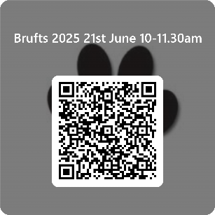

**S1-6 Hub104:** Hub104 IS ON this friday! It is our *last one* before the summer, there will be lots of games and Milkshakes available! See you there ☺️

**S1-6 Library Closed:** Library will be closed Friday breaktime. Reopen period 3.

**Ms Aleksandrowicz**

**S3 Wellbeing Week Wednesday:** All groups lists and meeting points are now up on the wall in the PE Department. Please check to make sure you know all of the details. Any pupils not on the list, please speak to Mr Collard ASAP.

**Mr Collard**