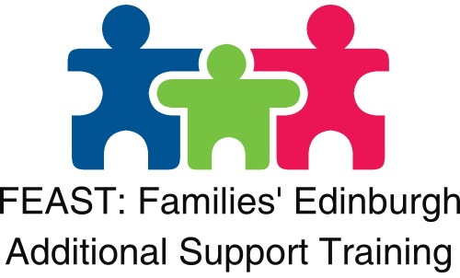

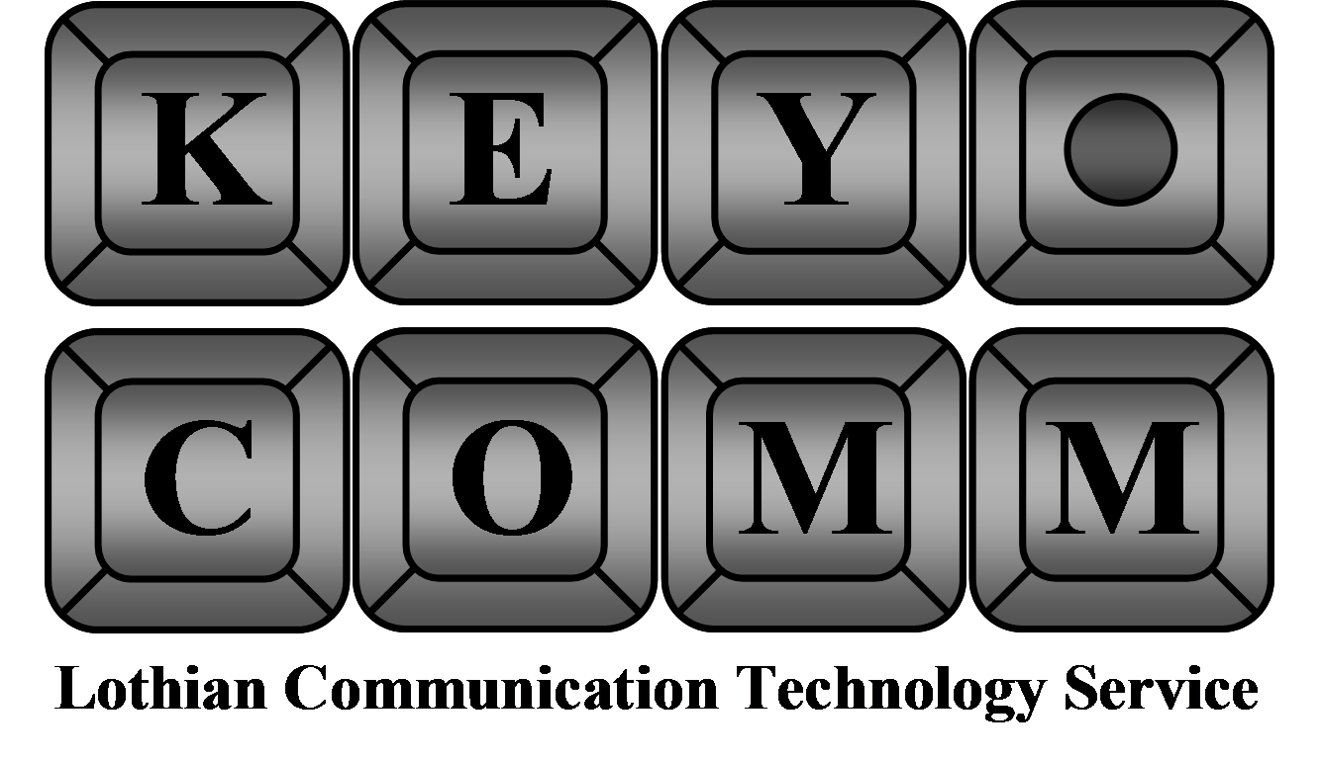

Communication and Literacy Using Technology
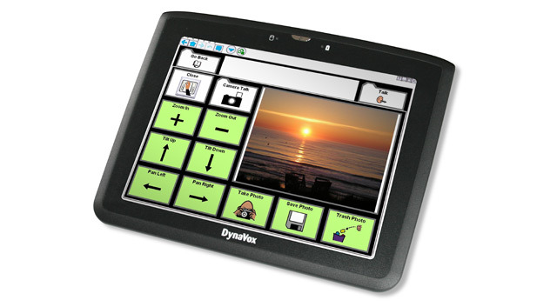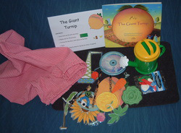  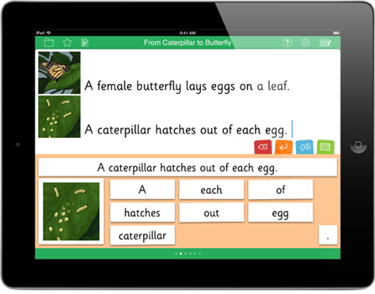  Some technology used to support communication and literacy. |  | This session will give you an opportunity to learn about the different technologies available to support your child’s communication and literacy at home.  The session will be in two parts:  - A hands-on tour of the various communication aids available from low-tech to high tech  - A workshop on supporting your child’s literacy skills using modern technologies including iPads and computers.  Come along and learn how to support your child’s communication and literacy!
Thursday 22nd February 2018, 10am-12.30pm, venue Oaklands School Conference Room
Keycomm Resource Centre
c/o Oaklands School
1c Pennywell Road
Edinburgh
EH4 4PH
Tel: 0131 311 7130

Please reserve ……… places for me at forthcoming Communication and Literacy training 22.02.18 10am-12:30pm

Name:

School Your Child Attends:

Child’s Name:

Child’s Stage eg P1/S3:

Please return the tear off slip to Keycomm or phone us directly to book a place. On 0131 311 7130 or email to janet.1.ramsay@ea.edin.sch.uk

