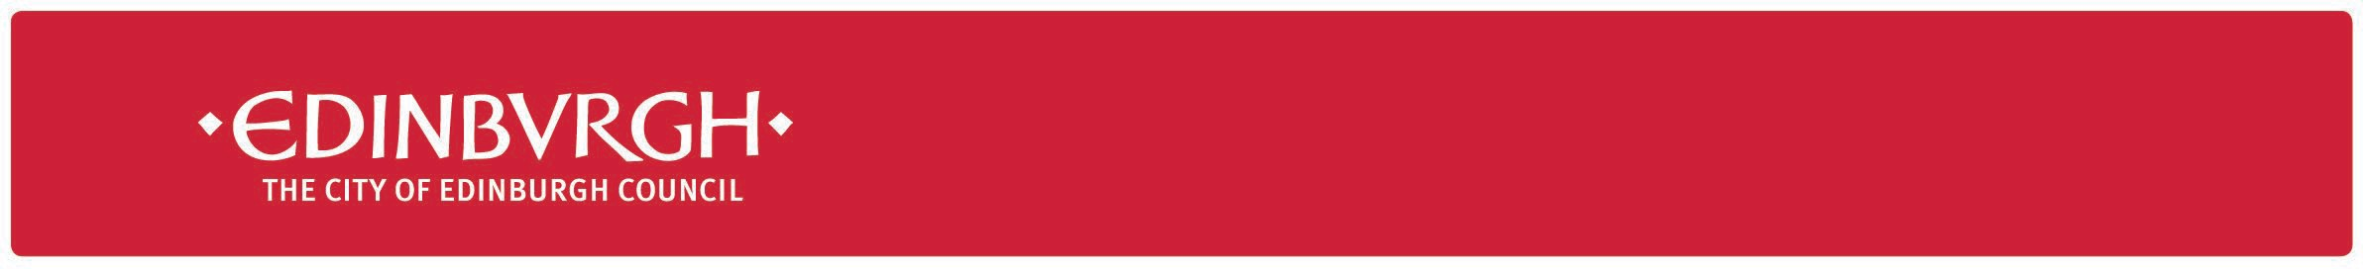

|  |  |
| --- | --- |
| **Date** | 27 September 2021 |
| **Your ref** |  |
| **Our ref** | S&LL/LF |

Dear Parents and Carers

With only a few weeks until the October holiday, it does seem as though our many combined efforts are having a positive effect - thank you.  COVID cases are beginning to decline and education in its many forms continues to flourish.  It has not been easy and as we prepare for winter, there will be more to be done to keep infection levels as low as possible.

However, I do have some news which you may have been expecting, and which you will hopefully find welcome.  The plans to celebrate the Queen’s Platinum Jubilee have been officially approved by the City of Edinburgh Council and for schools, this means that the Victoria Day (previously 23rd May) will now be celebrated on Thursday 2nd June and the Platinum Jubilee on Friday 3rd June, meaning schools will be closed.  This does mean another change to the annual calendar and I do apologise if it means some reshuffling for those of you who had already made plans for the long weekend in May.

The revised dates are now available on the Council website (<https://www.edinburgh.gov.uk/schools/term-dates>) and although it is a long way off, it’s definitely something to look forward to.

Meanwhile, I wish you a good week.



# Lorna French

**Acting Chief Education Officer**