Edinburgh Learns guide for parents, carers and learners:

Senior Phase Assessment, including National Qualifications and other SCQF Awards

Introduction
We understand that you may have a range of questions relating to the changes in SQA exam arrangements this year. This guide provides answers to the most commons questions we have been asked. It is dynamic and will be revised to reflect ongoing updates from SQA.

We would encourage our learners to contact their Pupil Support Leader at school if they are feeling unsure or even anxious about the new assessment arrangements as help is available.

Key Messages

- The Scottish Government has decided that National 5, Higher and Advanced Higher exams will not go ahead this school session 2020-21.
- Why? This is due to ongoing concerns about the impact of Covid-19 and the need to ensure that there is fairness and equity for all of Scotland’s young people.
- The Alternative Certification Model (ACM) for National 5, Higher and Advanced Higher will follow a similar process. This means that the teacher or lecturer will decide each learner’s provisional result by judging the assessment evidence gathered and checking the results with other staff in your school or college. This also means that coursework will not be marked by SQA, however it can still count towards evidence of your learning.
“the alternative approach will be based on teacher judgment, supported by assessment resources, and quality assurance.”

- Following the national Lockdown announced on 4 January 2021 and the extension announced on 19 January 2021, schools across Scotland will use remote learning until at least the middle of February.
- SQA have advised that the priority for schools and colleges during January should be to maximise learning and teaching time. Any planned formal assessments in January have therefore been postponed. We await advice from SQA regarding the period from end of January to mid-February.
- SQA is considering what impact this current period of Lockdown may have on the ACM for National 5, Higher and Advanced Higher courses. We await further advice from SQA about any potential changes to the Alternative Certification Model.
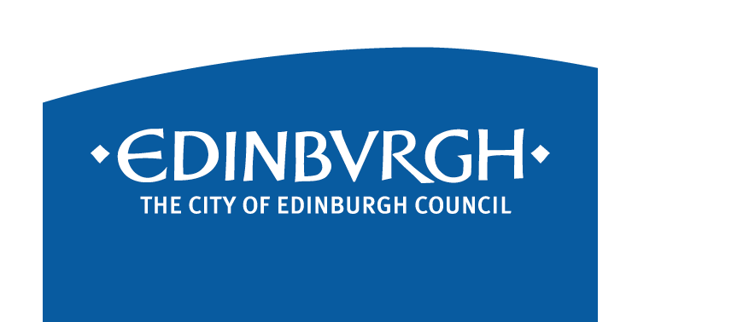
Frequently Asked Questions

What does the Alternative Certification Model (ACM) mean for me as a learner?
- Provisional results submitted during May 2021 will be based on evidence produced by the learner and teacher professional judgement using assessment resources. This will be supported by a robust set of checks (quality assurance) carried out by the child’s school (or college), The City of Edinburgh Council and SQA. The results will be finalised following various layers of quality assurance, including sampling by SQA senior subject specialists.
- The ACM aims to ensure fair and credible results for all learners undertaking National Qualifications.

How will I know how I am doing throughout the session?
- Teachers will keep you informed of your current attainment level as you progress through each qualification. Effective feedback should be provided following each assessment to ensure you understand your progress and next steps for learning.
- Teachers will indicate to you at appropriate points what grade you would be expected to achieve based on the evidence you are gathering. This should mean that there are no surprises for you when the provisional results for you are submitted to SQA.

Will the national lockdown announced on 4 January 2021 affect the ACM?
- Schools across Scotland will use remote learning until at least the middle of February. The National Qualifications 2021 Group is considering the impact lockdown will have on schools delivering National 5, Higher and Advanced Higher courses under the alternative certification model. It is working through a range of scenarios and considering any potential changes that might be needed.

Will teachers continue to gather assessment evidence during Lockdown?
- SQA have advised that the priority for schools and colleges during January should be to maximise learning and teaching time. Any planned formal assessments have therefore been postponed. We await further guidance from SQA about how schools would gather assessment evidence for the period from the end of January to mid-February, and beyond if remote learning continues.

How will teachers gather assessment evidence when pupils are in school?
- Schools are aiming to assess your learning at key points using appropriate assessment conditions.
- These ‘key points’ may be coordinated across the school using an assessment calendar. Various terms such as ‘assessment window’ or ‘prelim’ may be used to describe these formal assessments. Due to Covid-19 risk mitigations, schools may need to temporarily adjust the timetable to accommodate arrangements for assessments.
- Based on SQA and local guidelines each school can determine the most equitable and efficient means of gathering evidence and producing estimates.
- Some of you may have already sat assessments/prelims or may be due to sit prelims for NQ courses early in 2021. Whilst there is no requirement for schools and colleges to hold prelims, it is their decision. Results from prelims which have already been carried out or which are planned may count towards your evidence. Your teacher or lecturer can also use other types of evidence so speak to them if you are worried about this.
- The SQA has published broad guidance on evidence gathering and estimation to support schools.

What type of assessment evidence will be gathered?
- It is about the quality of evidence rather than quantity. The assessment load for learners and workload for staff needs to be managed carefully to support the health and wellbeing of all.
- SQA has outlined that the evidence of most value will be:
  - Ideally gathered as late as possible, in the unit of study, or course, to give you the best chance to show progress made. The evidence for some courses may be collected at an earlier point in the year because this is the most appropriate time for you to do the assessment.
  - Using an assessment that provides a similar level of challenge to the final SQA exam

Why is quality assurance necessary?
- Quality assurance is about fairness for you. A robust system of checks (quality assurance) is being put in place to make sure that a National 5 awarded in the north of Scotland is of the same standard as one which is awarded in the south of Scotland and everywhere in between.

How will the quality assurance model work in session 2020-21?
- Each school will use SQA guidance and assessment materials to help gather your evidence. This includes ensuring in advance that the assessments used are valid, reliable, practicable and fair. Your school and local authority will check your assessment evidence.
- Schools are supported in using the national standard (set by SQA) for when they decide your provisional results.
- SQA will request, review and give feedback on samples of assessment evidence from your school and/or college.
- Sampling ensures that all teachers/lecturers are making consistent and reliable assessment judgements against the national standard. This includes checking that assessment judgements are free from bias and that learners are treated fairly and equitably.
- Your school and/or college and local authority will look at SQA feedback and check your provisional results. The local authority will therefore set a deadline by which all gathering of evidence should be completed sometime in May so that there is sufficient time to do this checking of results.
- Your school and/or college will send your provisional results to SQA by 28 May 2021.
- From 5 June 2021 SQA will carry out a national check of the provisional results. They may follow up with your school and/or college about any issues they find.
- Any changes to your provisional results will only happen after your school or college talk to SQA, and once a senior subject specialist in SQA has reviewed the evidence sent in by your school or college.

How will I be supported if I have an Additional Support Need? Can I still access Assessment Arrangements (AA)?
- If you have an additional support need and have been identified as needing assessment arrangements (AA), these should, where possible, be in place for each assessment. Please speak to your subject teacher or Support for Learning Leader if you have any concerns about the AA process.
- Assistive features are built into iPad to complement vision, hearing, motor skills, learning and literacy. To look at Accessibility features on iPad, go to Settings > Accessibility
- https://www.apple.com/uk/accessibility/
- The Additional Support for Learning (ASL) Service have created a YouTube channel with videos on accessibility features: Additional Support for Learning Service Edinburgh – YouTube.

Due to the loss of ‘in-school’ learning time, caused by lockdowns, and the absences of some pupils and staff having to self-isolate, will this affect how well I do this year?
- It’s important to remember that learners across Scotland are in a similar situation, so the SQA, local authority and school are working hard to ensure you are not disadvantaged.
- SQA have made changes to N5, Higher and Advanced Higher courses to take account of this. For example, in PE you are assessed on one practical performance activity rather than two for N5. In other subjects, for example, you will have greater choice of topics to write about in assessments.
- Ensure that you are engaged in your learning now and maintain this, as much as possible, throughout the session. If you have any concerns, please speak to your teacher or Pupil Support Leader.
- Your school will have procedures in place to support anyone who is absent during the year. We are now making much better use of digital platforms, such as OneNote and Teams, to help you stay connected with your teacher and learning.

Will there be Study Leave and when will the Timetable changes happen?
- As there are no exams in May/June, there will no longer be any Study Leave. Due to Covid-19 risk mitigations, schools may need to temporarily adjust the timetable to accommodate arrangements for assessments.
- We are working with schools across the City to develop plans for learning in the summer term once the gathering of evidence for SQA has been completed. The school will confirm these arrangements once agreed.

How can I find out further information about the Alternative Certification Model?
- To stay up to date on 2021 National Qualifications visit www.sqa.org.uk/NQ2021
- SQA Messages to Learners:
  - 13 January 2021 - Update on National 5, Higher and Advanced Higher courses 2020-21
  - 16 December 2020 - Update on Higher and Advanced Higher courses 2020-21
  - 8 December 2020 - Delivering your National 5 results in 2021
- SQA Messages to Parents & Carers
  - 13 January 2021 - Update on National 5, Higher and Advanced Higher courses 2020-21
  - 16 December 2020 - Update on Higher and Advanced Higher courses 2020-21
  - 8 December 2020 - News about National 5 results in 2020-21

