 | Date | 04 November 2020
 | Your ref
 | Our ref | S&LL/AG/JR

Dear Parent/Carer

I am writing to you to enlist your support in encouraging your child to wear a face covering while in school.
The latest Scottish Government guidance is that pupils in the Senior Phase – S4-6 – and their teachers should wear a face covering in classrooms, as well as when they are moving around the school and in communal areas. Pupils in the Broad General Education – S1-S3 – may choose to wear a face covering if they wish to.
While individual exemption can be negotiated at school level according to the Scottish Government guidelines, the wearing of a face covering by all those without such an exemption is an important mitigation in controlling the spread of COVID-19 and your encouragement for your child to do this would be much appreciated.

Kind regards
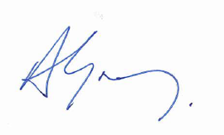

Andy Gray

Head of Schools and Lifelong Learning
Chief Education Officer

