

**The New Boroughmuir High School**

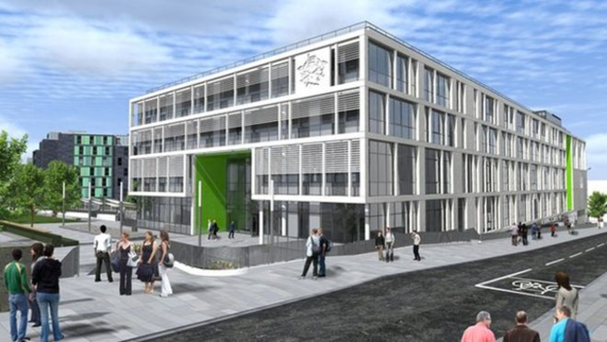

**Please respect and look after our new building**

Recycling & rubbish bins are provided. Please use them.

Keep chewing gum out the building and the school grounds.

Eating areas are the playground, atrium, terrace and lower atrium

These are also your social areas

Food and drinks cannot be taken above atrium level or into classrooms (except water)

Floors above the atrium are out of bounds at break and lunch

Keep the reception area clear at all times

Help the flow around the building. Keep LEFT in corridors and stairs.

* The Reception staircase can be used to go up or down from the south entrance to the atrium.
* The Atrium staircase is for downwards traffic only
* The Servery staircase is for downwards traffic only
* The 4 corner staircases are for moving up and down between floors

Don’t lean over the balconies and be careful of dropping things from them.

**Enjoy and look after the new school. It’s yours!**

**Boroughmuir High School**

**111 Viewforth**

**Edinburgh**

**EH11 1FL.**

**0131 229 9703**

[www.boroughmuirhighschool.org.uk](http://www.boroughmuirhighschool.org.uk)

[admin@boroughmuir.edin.sch.uk](mailto:admin@boroughmuir.edin.sch.uk)

