

**Community Newsletter for**

**The New Boroughmuir High School**

**55-63 Dundee Street, Edinburgh**

**October 2015**



**About the Project**

O’Hare & McGovern have been appointed by the City of Edinburgh Council for the construction of the new Boroughmuir High School. The project is part funded by the Scottish Government through their ‘Scotland’s Schools for the Future’ programme which is managed by the Scottish Futures Trust.

This newsletter demonstrates our commitment to ensuring local residents are kept fully informed on the progress of the development and construction activities.

We commenced operations on site in October 2014 with the expected project completion mid September, 2016.

O’Hare & McGovern prides itself on having a strong and impressive health, safety and environmental record with these issues given top priority. This is evident via our membership of the Considerate Constructors Scheme, through which our site is judged in respect for the environment, consideration of the cleanliness of operations, respecting our neighbours and safety.



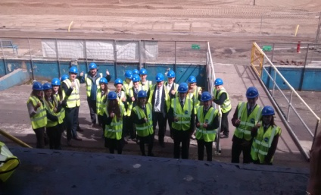

O’Hare & McGovern are committed to maximising local employment and training opportunities on this project through the provision of placement opportunities for a number of apprentices, long term unemployed and undergraduates in partnership with local schools, colleges and universities.

Any issues or concerns by adjoining residents will be addressed immediately, with all enquiries handled directly by O’Hare & McGovern’s Project Manager, Gary Thomas, who can be contacted by e-mail at gthomas[@ohmg.com](mailto:ngillespie@ohmg.com) Tel: 07525815539. In the meantime, it is the intention of O’Hare & McGovern to keep all residents fully informed on the ongoing works.

**Project Team**

Please see below our management structure for this project.

[](http://www.ohmg.com/)

**Gordon Baker Design Manager**

**David Harries**

**Site manager**

**Tony Sweeney Project Manager ManagerManager**

**Contact Details for O’Hare & McGovern**

|  |  |
| --- | --- |
| **Head Office**  O’Hare & McGovern Ltd  Carnbane House  Shepherd’s Way  Newry  Co Down  BT35 6EE  Tel: 028 3026 4662  Fax: 028 3026 2747 | **Site**  O’Hare & McGovern Ltd  63-76 Dundee Street  Fountainbridge  EH11 1AL  Tel 07736290407  E-Mail: [carnbanehouse@ohmg.com](mailto:carnbanehouse@ohmg.com)  Website: [www.ohmg.com](http://www.ohmg.com) |

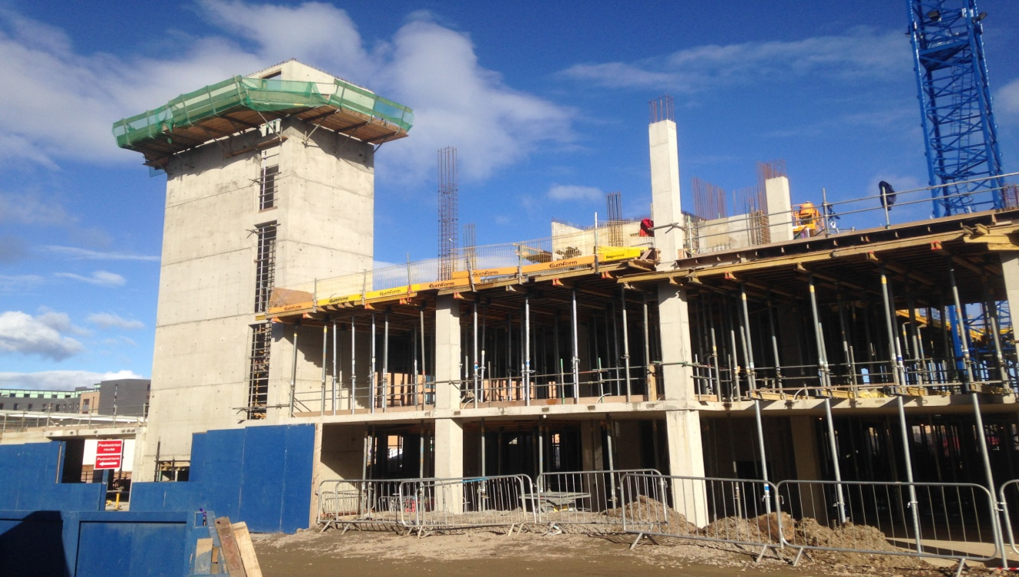

**Key activities**

* Level +0 post tensioned slab is nearing completion towards the rear canal end of the site.
* Level +1 post tensioned slab is currently being formed and poured. This process will be repeated along the length of the structure. Level +2 will closely follow.
* Stair Core 3 and 4 at the canal end of the site are beginning to rise.
* 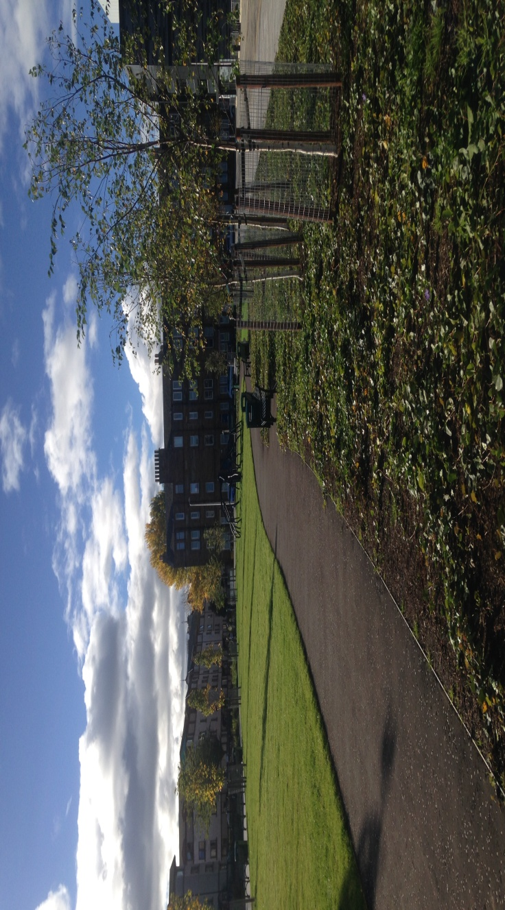Design development is continuing on the external and internal elements of the building.
* The community park space running adjacent to the Union Canal tow path has been handed over to the City of Edinburgh council and opened to the public.
* Ground works will continue across the site, with access routes within the site boundaries expected to change in the coming weeks.
* Looking forward, the extensive road works package is expected to start in the coming weeks.

**Temporary Pedestrian Routes**

* Pedestrians should exercise caution when crossing the materials site entry due to traffic movement.
* Viewforth Street will encounter temporary traffic management due to ongoing works.

**Daily Traffic Movements**

* Site Deliveries
* Plant equipment

**Construction Working Hours**

* Normal working hours are between **0700-1800** Monday to Friday and **0800-1300** on Saturdays as required.

**Site Safety**

All measures have been taken to ensure that the site is securely and safely segregating the public and adjacent properties from work activities. We would however respectfully request that parents and guardians remind children and minors that construction sites are dangerous and although all site activities are tightly controlled they should not be seen as play areas as there is a serious risk of injury or fatality.